# Topics

* Previous PC lab
* Syntax
* Computational thinking
* Tic Tac Toe

**10.1.2. if-else statement**

**for loops**

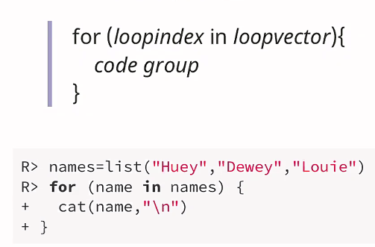

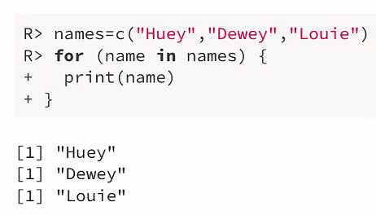

# Nesting for loops

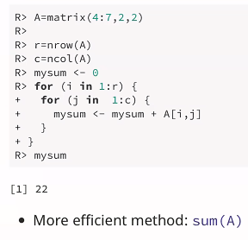

**10.2.2 while loops**

* While loop is executed until the loopcondition is false!

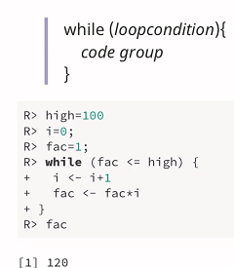

# Computational thinking

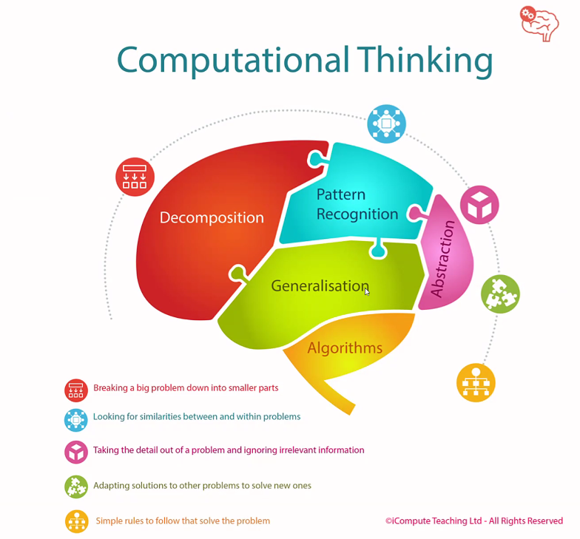

# Tic Tac Toe

* Which steps do we need?
  + - Drawboard
    - Player starts
    - Ask players move
    - Do move
    - Determine winner
    - PC move
    - Check whether the board is full

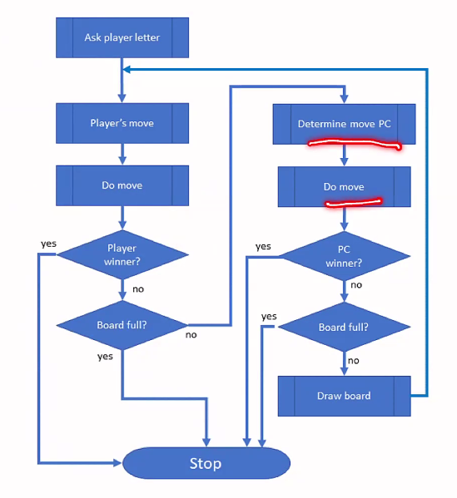

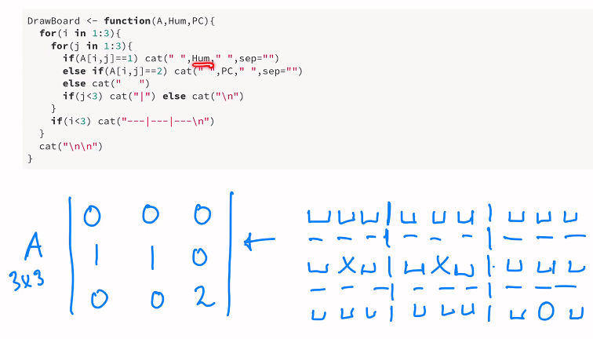

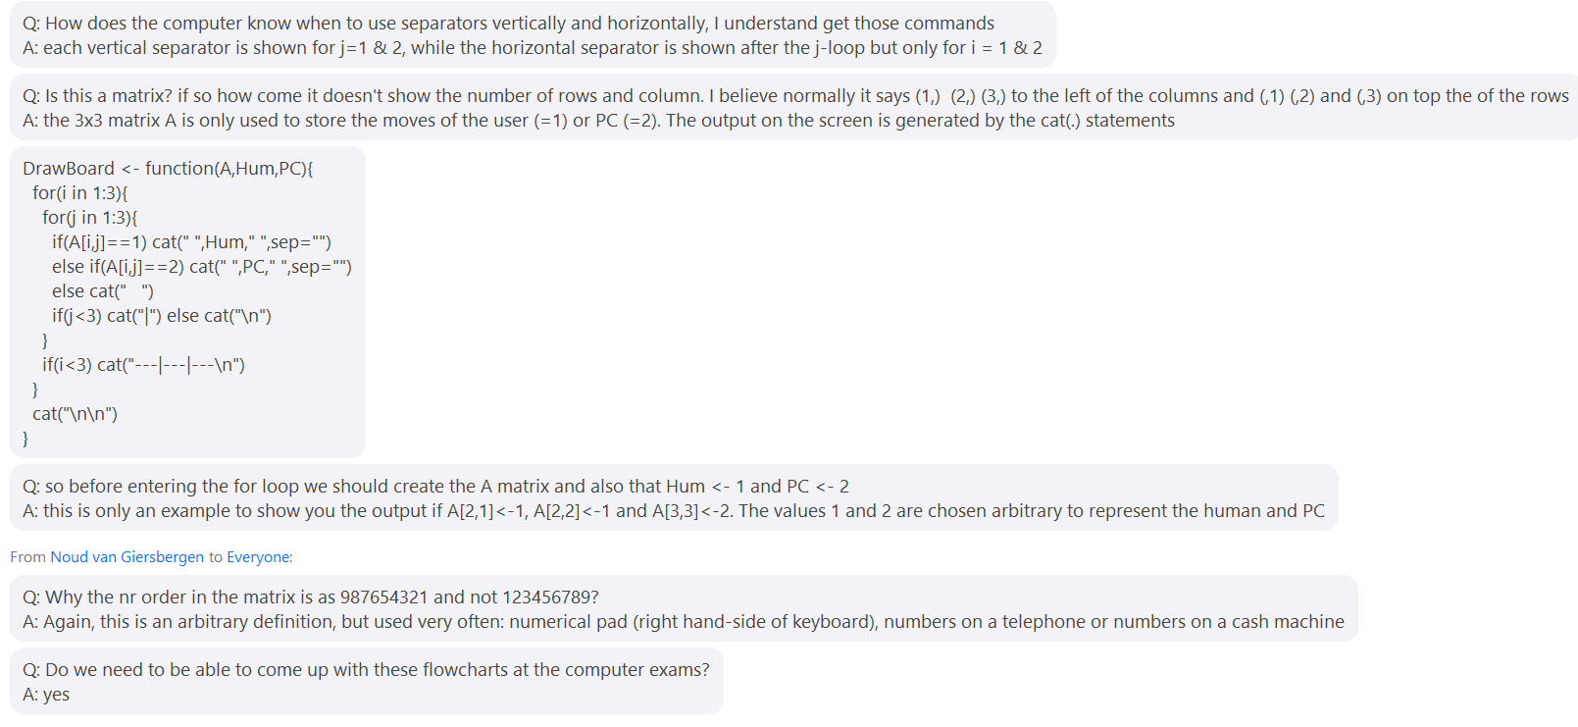

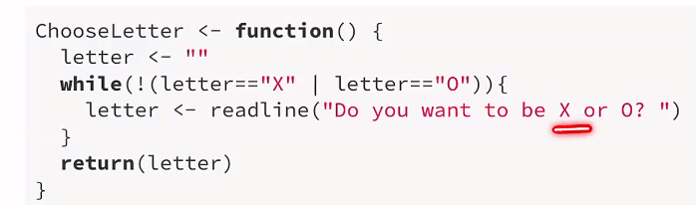

HumanFunction –

